1.inventory during customer checkout process.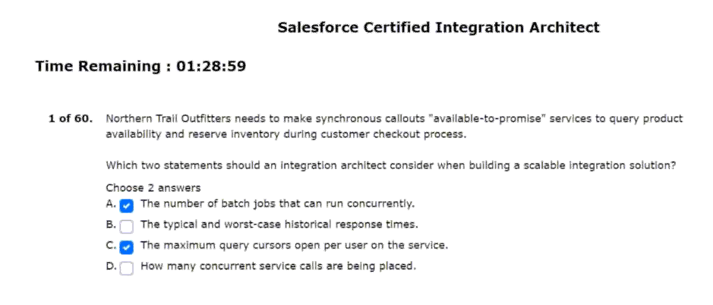
2.keeps them synchronised via platform events.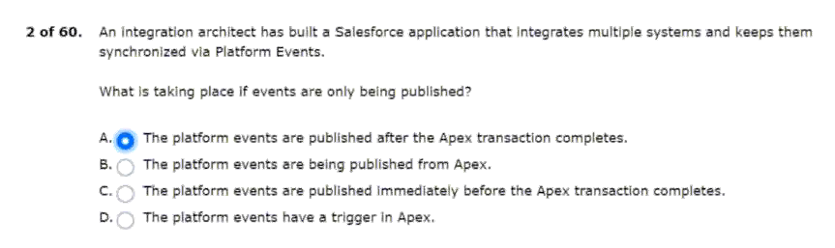
3.integration often experiences latency issues.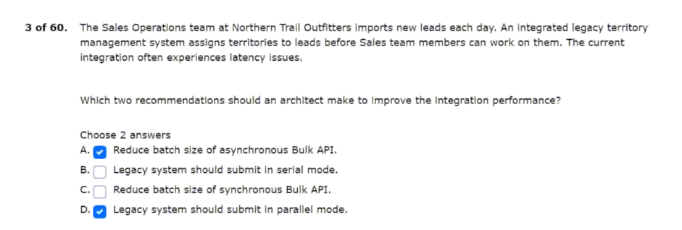
4.masters all courses and student registration.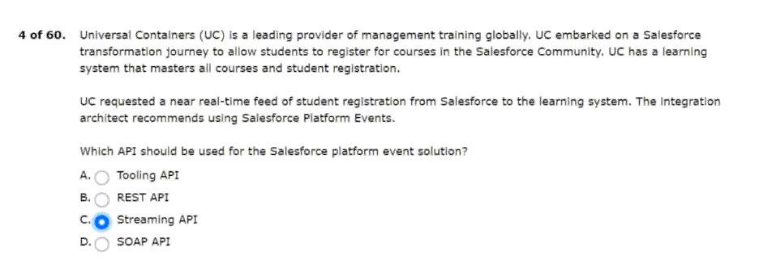
5.security and strict auditing requirements: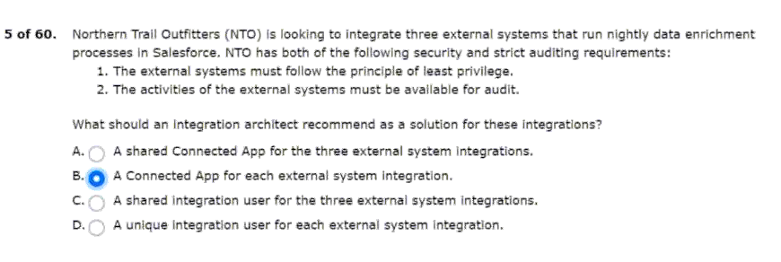
6.request shipping estimates from that service.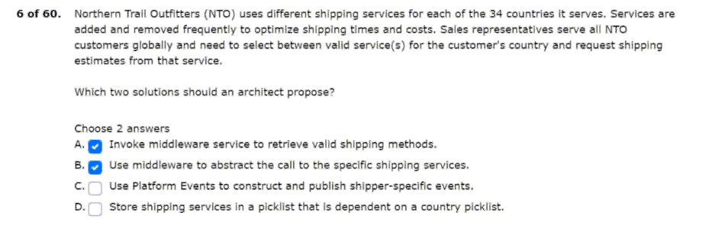
7.to view the design files in the community.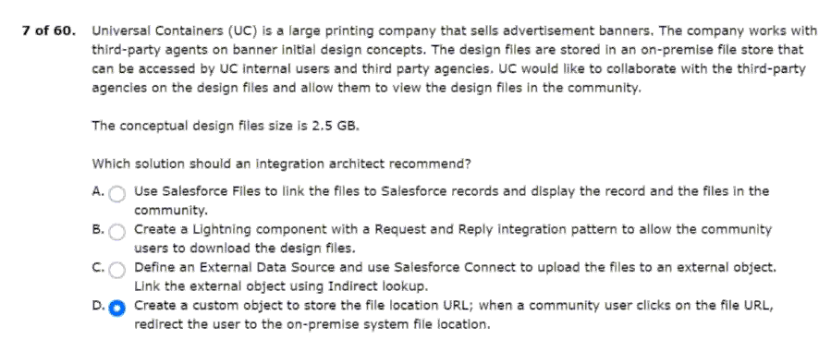
8.limited outside access to external systems.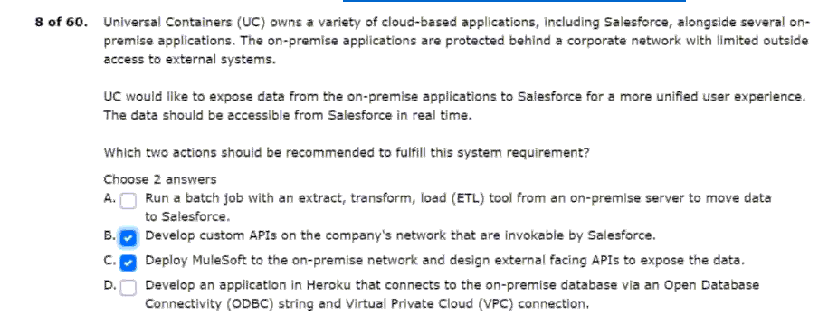
9.data needs to be reflected in the lms.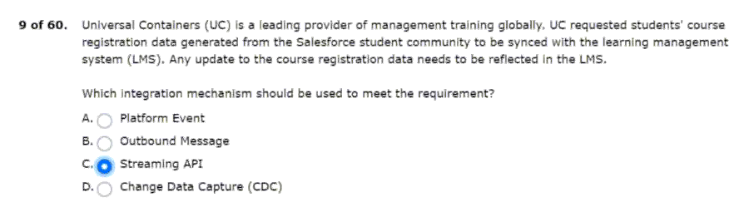
10.invoices from a given set of orders.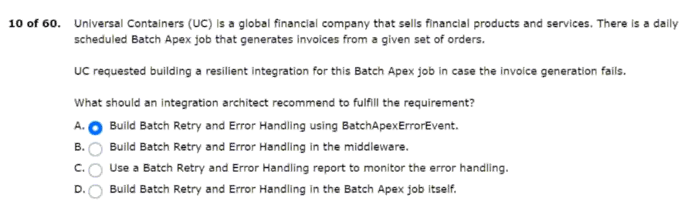
11.NTO has the following requirements:
Recipe and data syncs
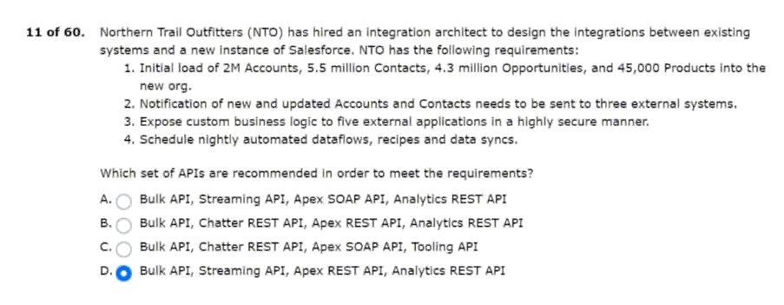
12.the number of closed cases in real time.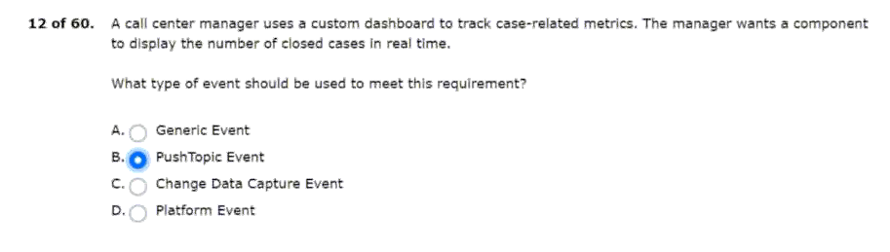
13.salesforce supports are critical to the business.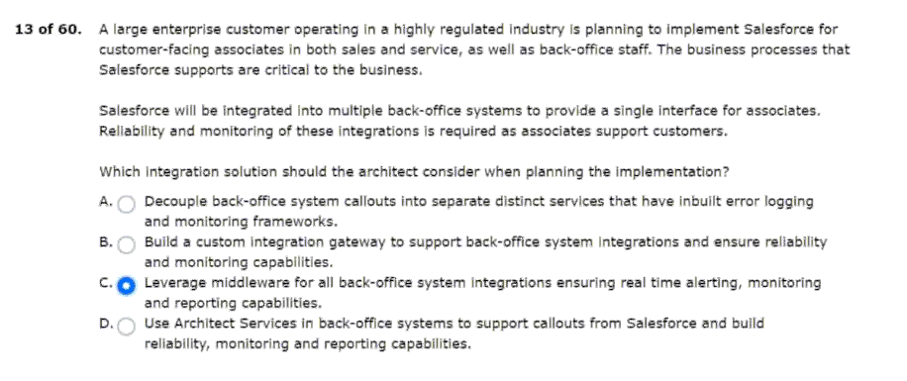
14.enterprise systems and salesforce platform limits.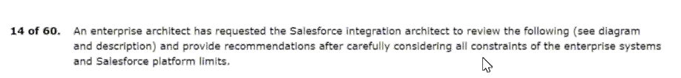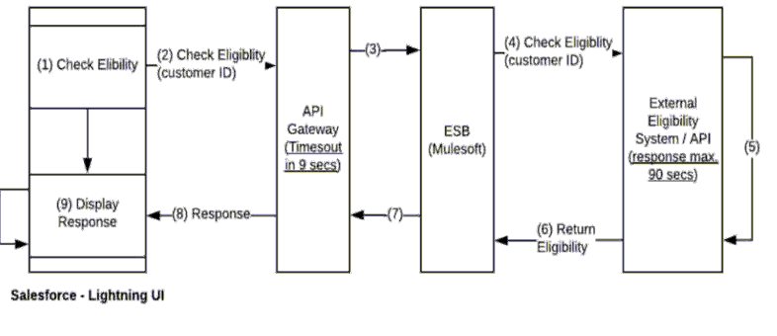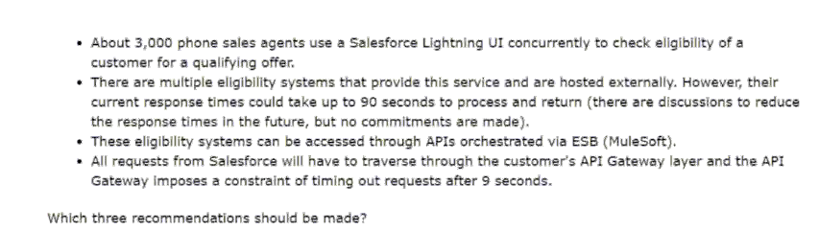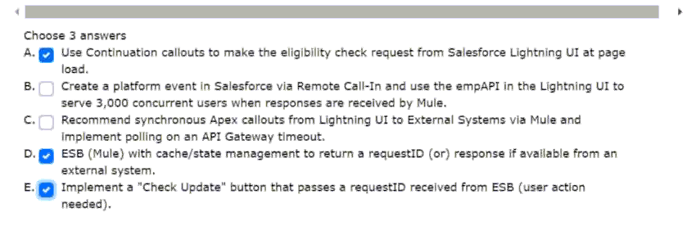
15.the company will complete the following: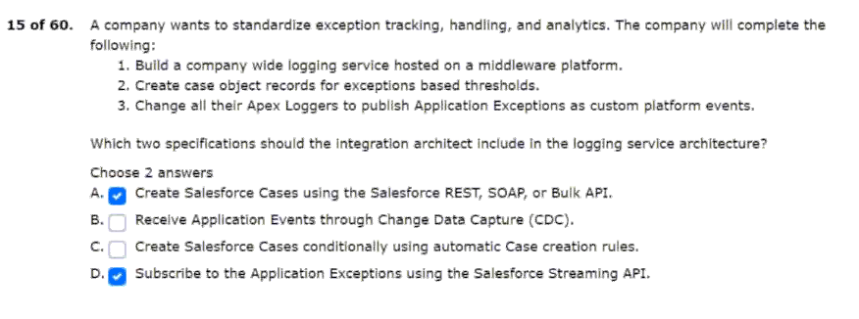
16.data to only persist in the external system.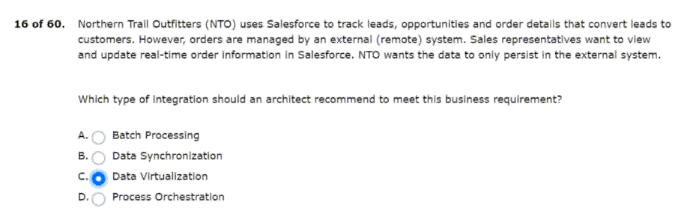
17.application should be kept synchronised for consistency. 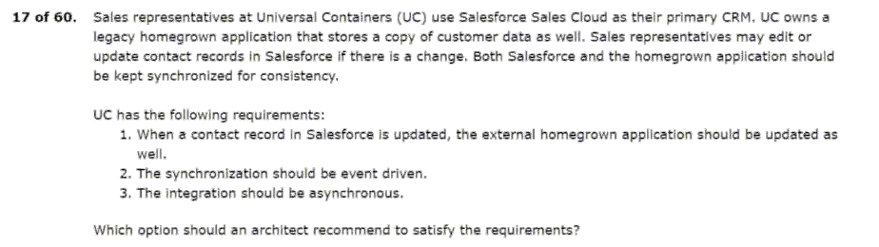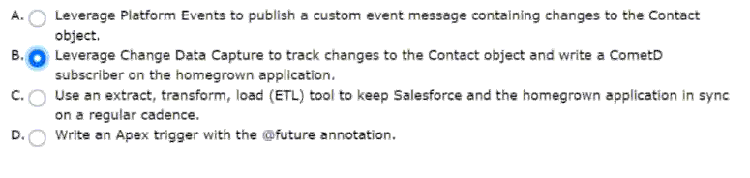
18.in order to meet a business requirements.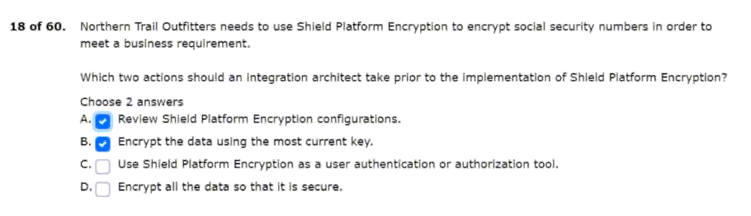
19.their internal systems and salesforce.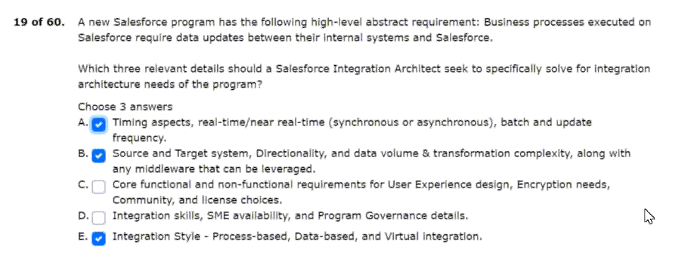
20.authorize after installation of the package.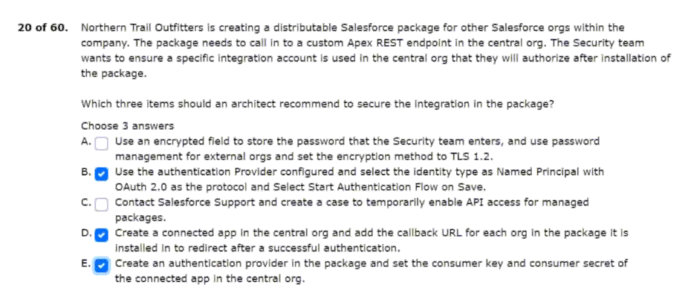
21.with no-premise resources and services.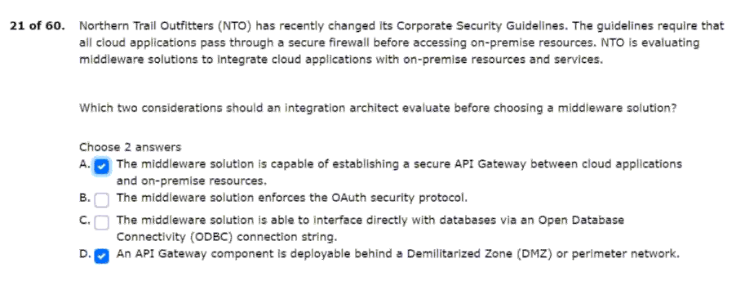
22.is a business critical function for end users.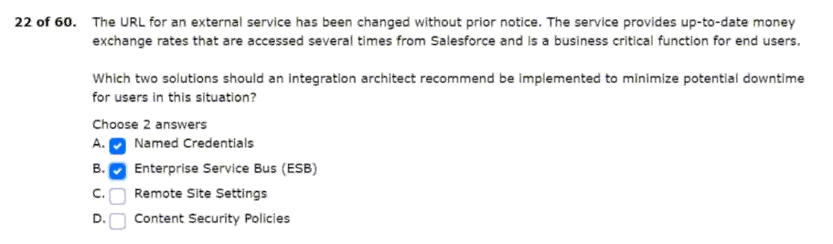
23.and has requested a solution recommendation.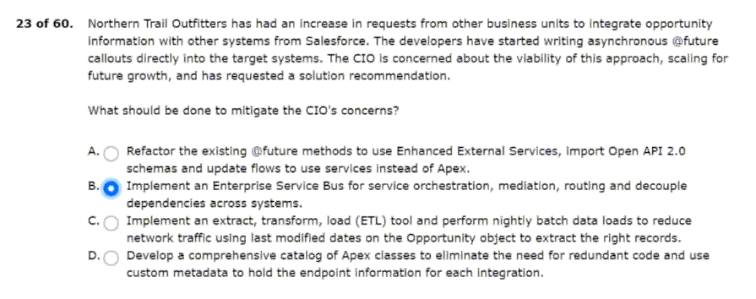
24.systems and condition in their landscape: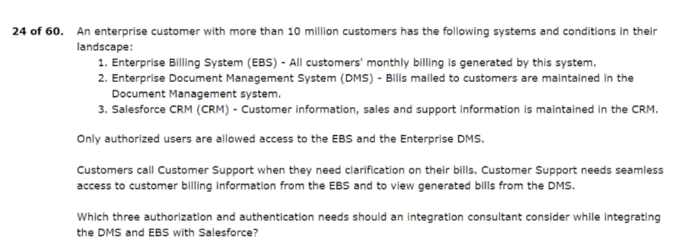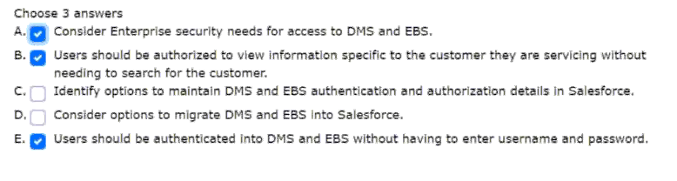
25.the following conditions exist: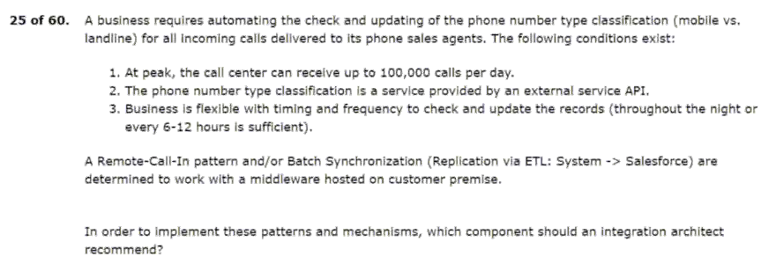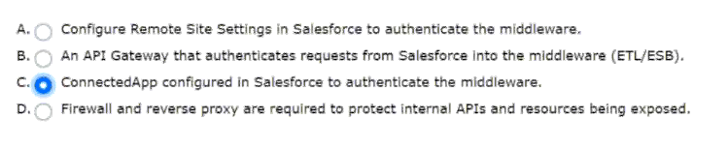
26.and oauth tokens used in callouts from salesforce.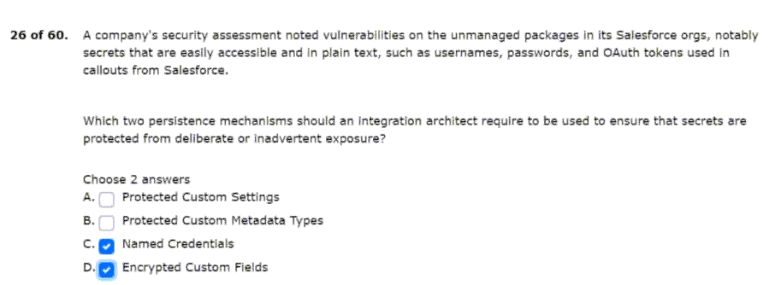
27.from salesforce to on-premise servers.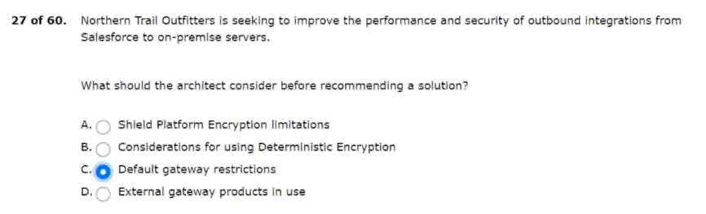
28.using rest api to avoid architecture changes.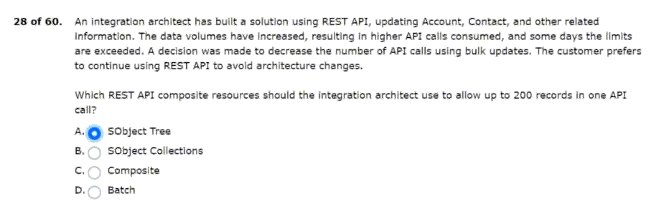
29.store them on a custom geolocation field.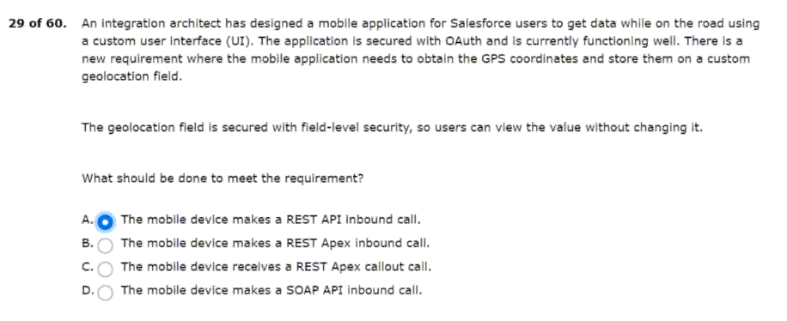
30.planning to implement salesforce sales cloud.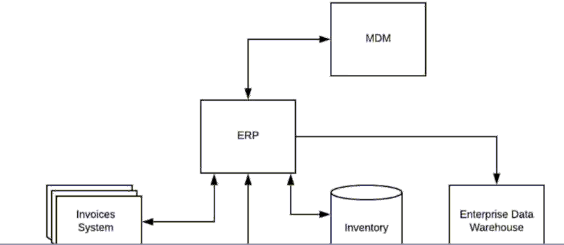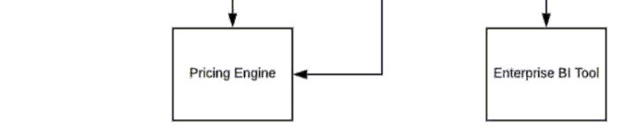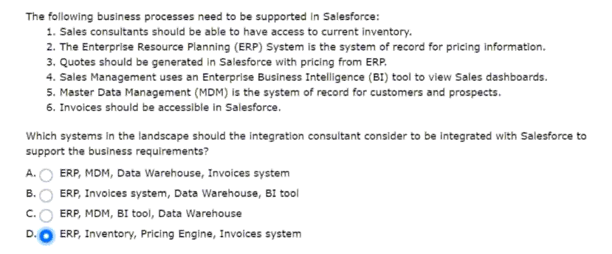
31.the events are as follows:
Meet these business requirements?
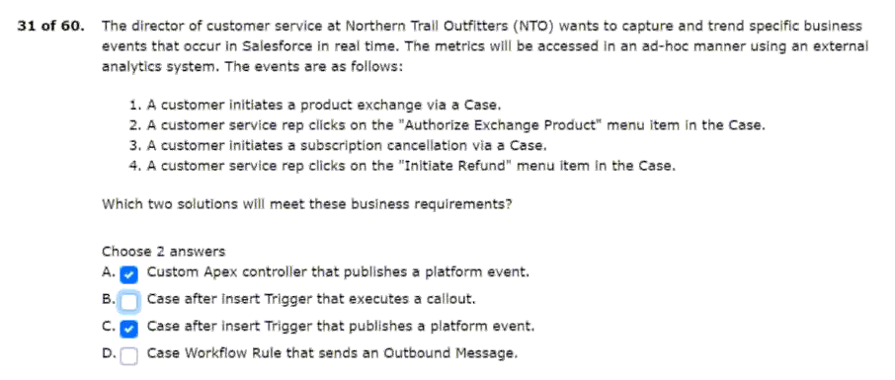
32.company portal use ssl mutual authentication?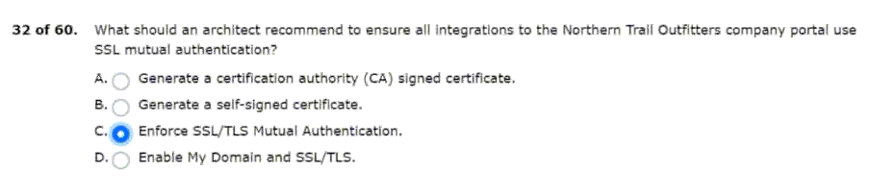
33.will be approximately 1 million contacts per month. 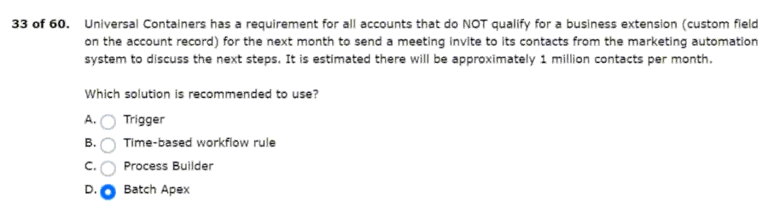
34.response back in a strongly-typed format.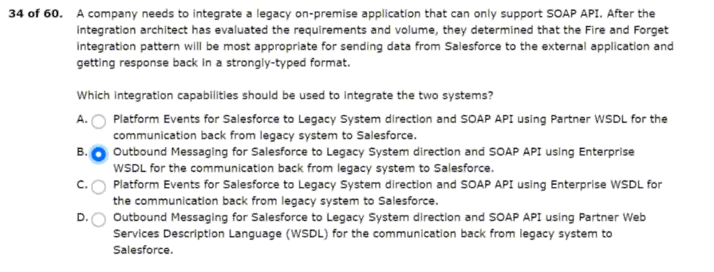
35.such aspects with their salesforce program.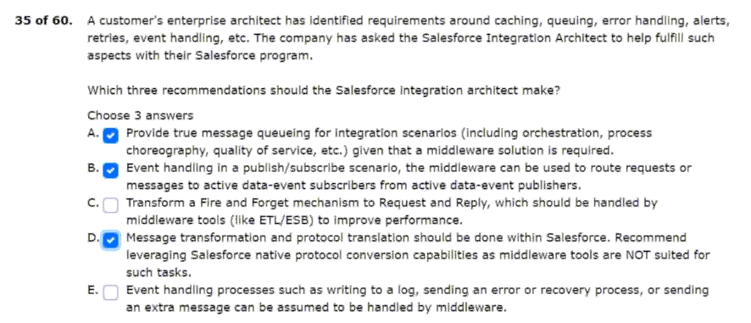
36.the students can retry the payment process.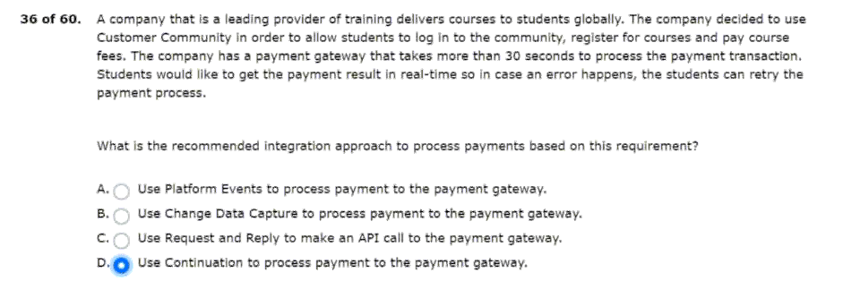
37.the current system landscape includes the following: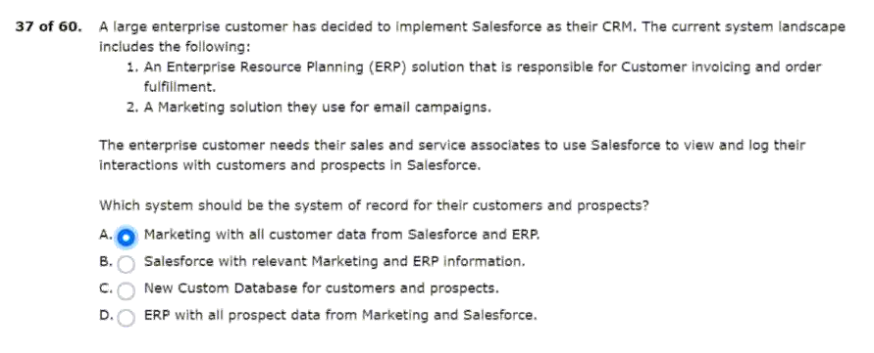
38.with an apex callout due to technical constraints.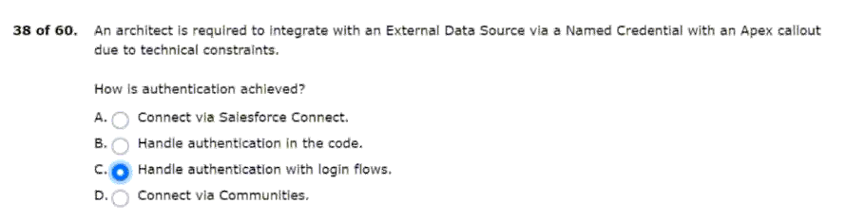
39.with an external system for a company.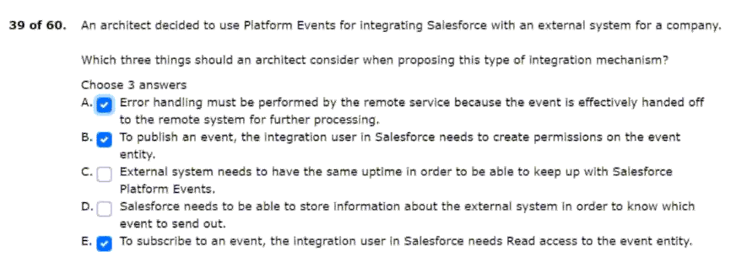
40.their legacy application with salesforce. 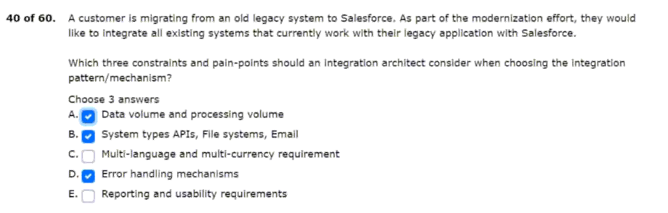
41.currently, uc has the following systems: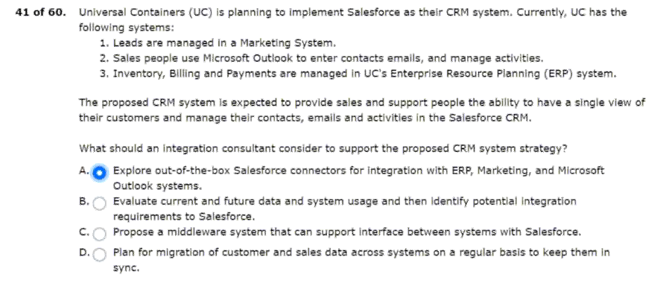
42.resources and requires a low-code solution.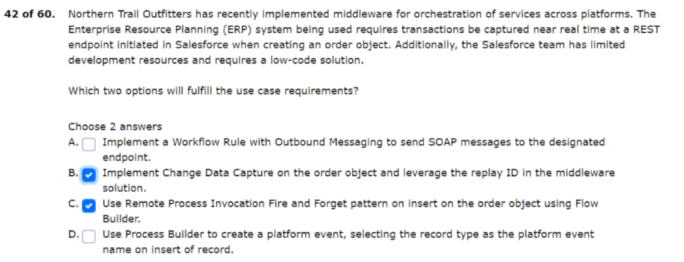
43.salesforce org and different metadata?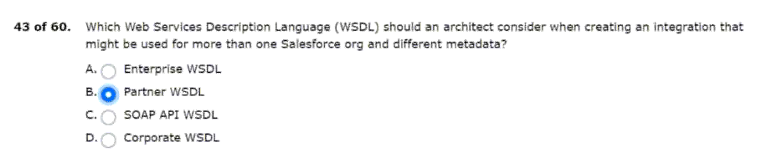
44.from salesforce to a fulfilment system?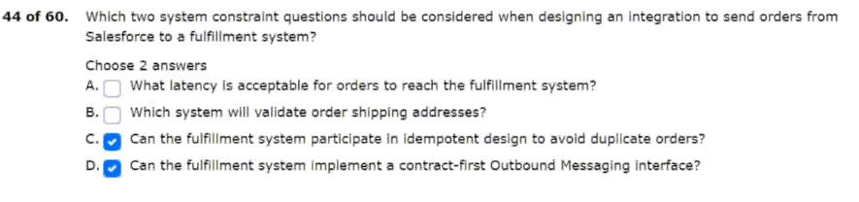
45.who are inquiring about uc bank accounts.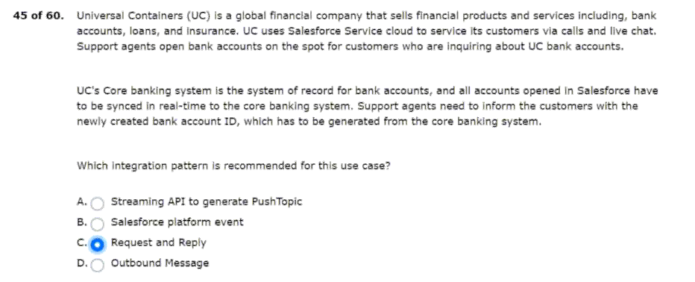
46.will be taken down for maintenance.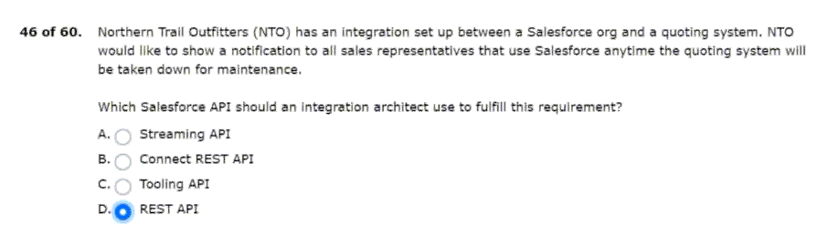
47.that apex rest api clients can rely on.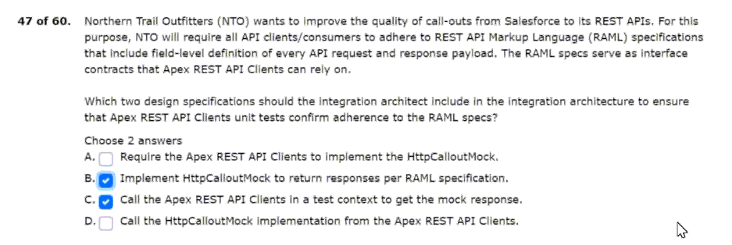
48.this system must remain on-premise.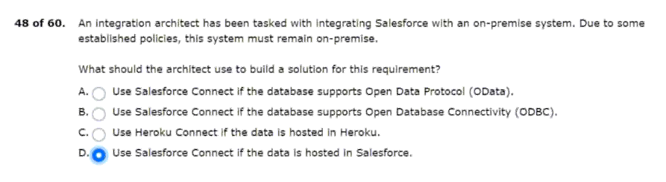
49.below is their current system landscape diagram.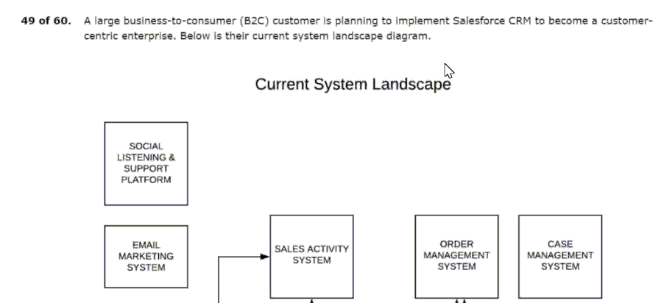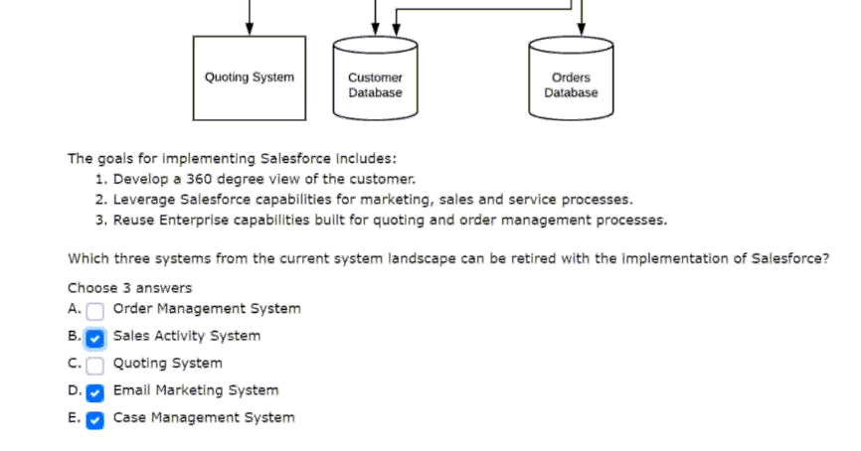
50.and services that include the following: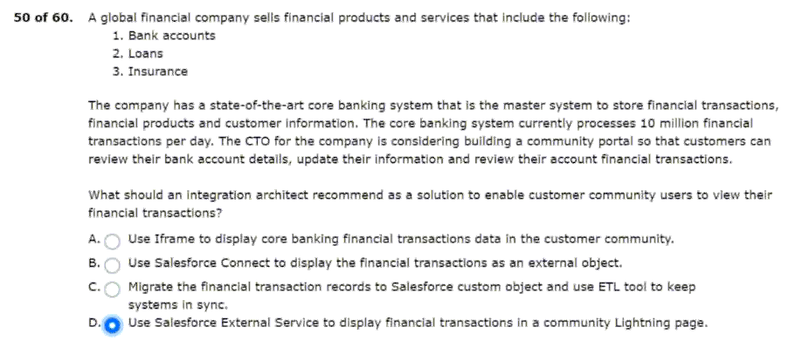
51.in boolean and string values data types.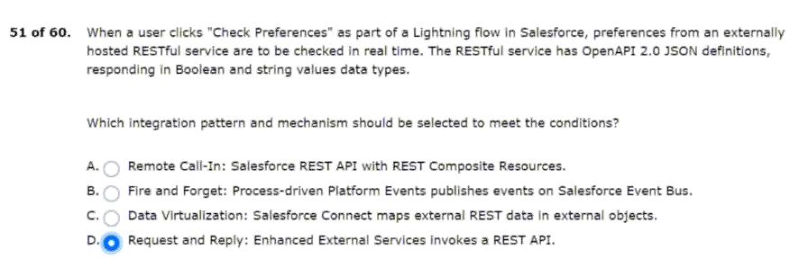
52.even when the client re-connects every couple of days.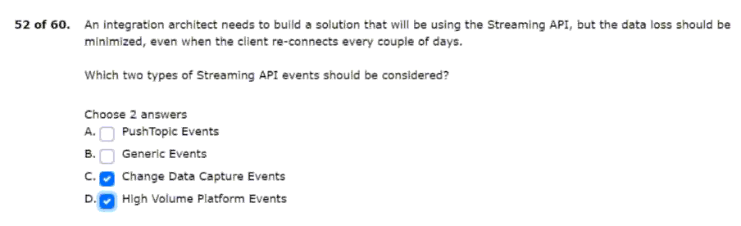
53.for customers who inquire about uc products.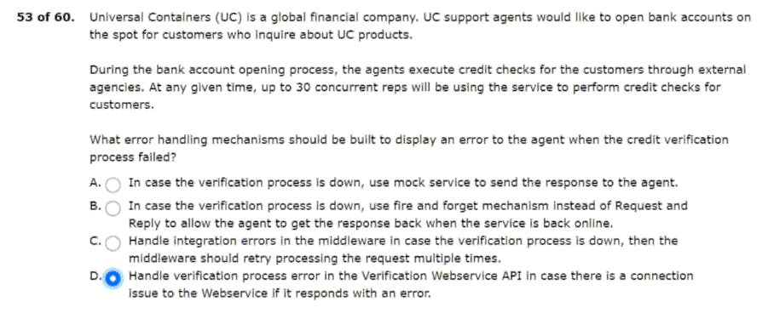
54.and plans to include salesforce as well.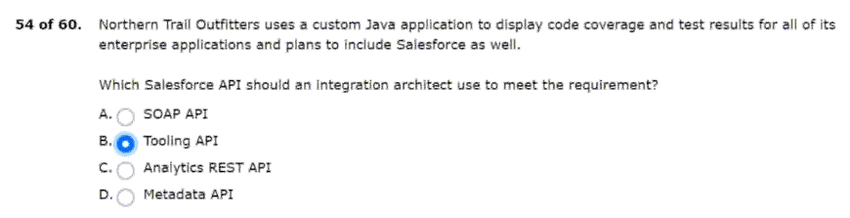
55.self-registration and single sign-on (sso).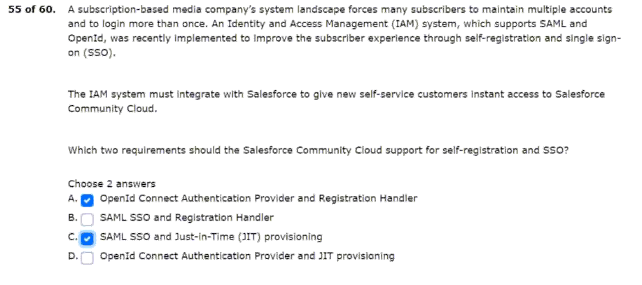
56.system architect for some guidance.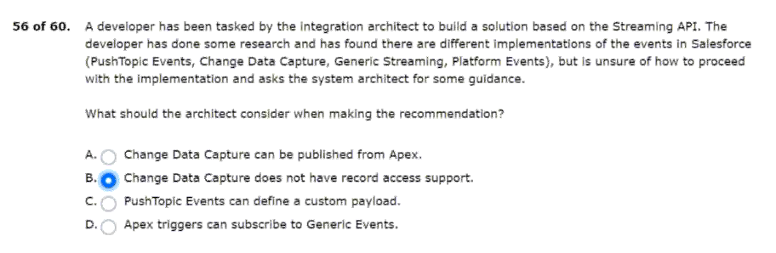
57.using the lead-to-opportunity process.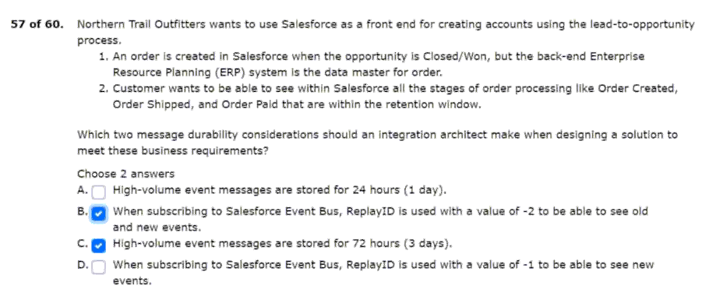
58.any degradation in salesforce performance.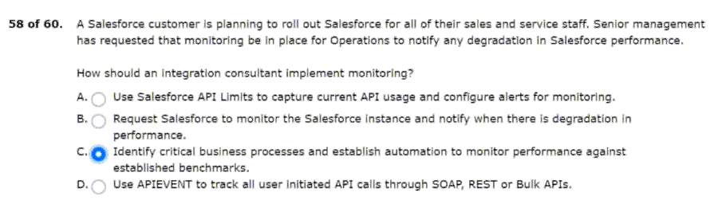
59.soql query filtered by sharing hierarchy.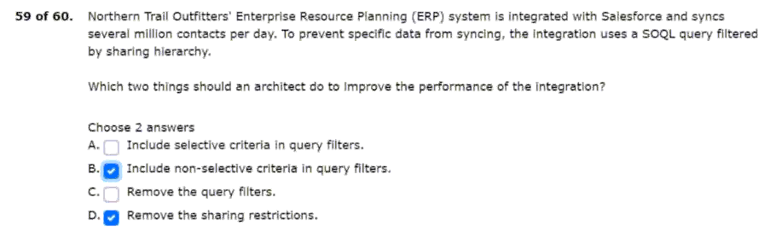
60.component to an external endpoint is falling?